**Capstone Project 1 - Predicting Automobile Accidents in Montgomery County**
Can accident frequency be predicted for automobiles based on particular factors? In this capstone project the data from Maryland's Montgomery county traffic stop database is used to look at variables that could potentially help predict increased accident likelihood.

-Can accidents be predicted based on the month?
-Is there a connection between certain colors of automobiles being in more accidents due to their color, or is it more a popularity of that color leading to more of them to have more accidents?
-Can a recommendation be made on certain colors being safer automobiles?
-What caused the year 2017 to have more accidents?
-Did alcohol affect the amount of accidents with any significance?

Future questions - Can accidents be predicted based on the day of the week (weekday, weekend)?
Can conclusions be made that driving a certain color car on a certain day of the week is more likely to get in an accident vs other car colors?

Question: Can missing data be identified and can we see where there may be missing values?
Answer: 1,632,871 is the total number of non-null objects recorded. Any category without this full amount is missing information.

Question: What vehicle types are listed in the data set? What would be a good representation for a general population to sample?
Answer: There are over one million automobiles in this data set. This would be primarily the focus for most consumers and the clients identified for this study.

Question: How many of each color automobile exists in the data set?
BLACK 302920
SILVER 277374
WHITE 204921
GRAY 170297
RED 112190
BLUE 107037
GREEN 50681
GOLD 45461
BLUE, DARK 30384
TAN 29503
MAROON 23658
BLUE, LIGHT 18778
BEIGE 16738
GREEN, DK 14368
GREEN, LGT 7831
BROWN 6246
ORANGE 5036
YELLOW 4234
BRONZE 3179
PURPLE 2683
CREAM 845
MULTICOLOR 510
COPPER 430
PINK 192
CHROME 40
CAMOUFLAGE 25
Question: When comparing the percentage of the represented colors for all vehicles to represented colors for only automobiles, are they similar enough to give an accurate assessment for what this study is looking at to use only the automobiles as the sample dataset?
Answer: The percentage of the represented colors for all vehicles vs. represented colors for only automobiles have similarity to give an accurate assessment for what this study is looking at to use only the automobiles as the sample dataset. For example Black is 20.75% and 21.10%, Gray is 11.53% and 11.86%.

Question: What is noticed in the number of automobiles in accidents compared to those not in accidents?
Answer: There is quite a difference between the number of automobiles in accidents versus those not. Also interesting to note how many more vehicles of certain colors exist in this sample and then consider if this affects the outcomes of those having higher accident rates.

Question: Does the percentage of those more popular colors show a higher likelihood to be in an accident?
The chosen dataset of only the Automobiles from the database of vehicles that were stopped in Montgomery county. It is not surprising that the most popular colors are black, silver, white, gray, red, and blue. It is a consideration if drawing a conclusion that black cars get in more accidents than brown for example. Therefore, there was a need to look at the percentage of accidents of a color, out of the total vehicles of only that color.
Answer: According to the results, COPPER is the least likely to have been in an accident through the span in this sample, with multicolor being the most likely. This raises a flag to ask questions; What colors are in the category of MULTICOLOR? Why might COPPER be such an outlier?

Question: When looking at automobile stops broken by color, are more vehicles in accidents compared to those not in accidents across the board or vice versa?
Answer: Visually looking at the difference between those in accidents vs. not in accidents tells overall most vehicle stops are not accident related across all colors.
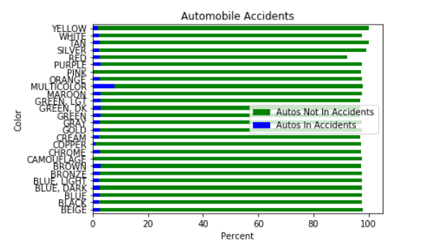

Question: This is where we begin to see if not only color can help predict an automobiles chance of being in an accident. Are certain months more prone to have accidents? Further looking to see if certain years had more accidents? Can a cause for this spike be identified and is it possible it will occur again? On the reverse, if certain year had less accidents, can this cause be identified so that perhaps we can reduce accidents annually?
Answer: There is a spike in 2017 and a low in 2012. Several months in 2012 are low compared to all months. September, October, and December of 2016 are significantly higher than most months recorded. Time to consider what causes this. Are there less vehicles on the road due to weather, the economy, politics, etc.? Now to identify if these are event that could occcur again and be predicted, leading to potentially reducing annual and monthly accidents.
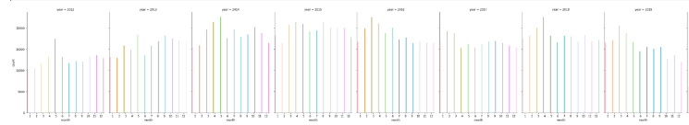
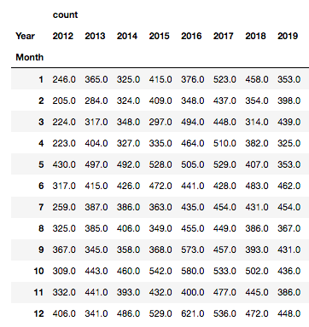

Question: What was the distribution for the number of automobile stops that were considered accidents each day over the entire span?
Answer: Below shows the maximum number of accidents in one day through the years was 56. The minimum being 1. The average, mean, per day over all years was about 12 accidents.
count 2908.000000
mean 12.017538
std 8.065481
min 1.000000
25% 6.000000
50% 10.000000
75% 16.000000
max 56.000000

Question: What was the distribution for the number of automobile stops that were considered accidents each month over the entire span?
Answer: Below shows the maximum number of accidents in one year through the years 22,601. The minimum being 7,372. The average, mean, per year over all years was about 16,932 accidents.

 | count
count | 97.000000
mean | 408.164948
std | 83.727320
min | 203.000000
25% | 353.000000
50% | 409.000000
75% | 458.000000
max | 621.000000

Question: Does alcohol appear to have any significance in traffic stops for automobiles in accidents?
Answer: The percentage of vehicles in accidents that involved alcohol vs. vehicles in accidents in each color. This is a small percentage.
BLACK 0.135073
BLUE 0.045982
GRAY 0.045982
TAN 0.040235
MAROON 0.037361
WHITE 0.020117
BLUE, LIGHT 0.002874
GOLD 0.002874
For example, 47 out of 6,788 black automobiles in accidents involved alcohol. There was a total of 302,920 black automobiles overall.

